Automation of Forms to MySQL DB and Pizza Delivery and Student Migration Summary reports in power BI

The domain of the Project:

SQL AND POWER BI

Under the guidance of

Ms. Siddhika Shah Software Engineer At HCL Technologies

Prof. Radha kumari Executive Director & Founder SURE Trust

By
Mr. Devesh Kushwaha (Pursuing BCA)

Period of the project

May 2025 to August 2025

SURE TRUST PUTTAPARTHI, ANDHRA PRADESH

Declaration
The project titled “Automation of forms to MySQL DB and Pizza Delivery and Student Migration Summary reports in power BI” has been mentored by Ms. Siddhika Shah, organised by SURE Trust, from May 2025 to August 2025, for the benefit of the educated unemployed rural youth for gaining hands-on experience in working on industry relevant projects that would take them closer to the prospective employer. I declare that to the best of my knowledge the members of the team mentioned below, have worked on it successfully and enhanced their practical knowledge in the domain.

By: Signature
Devesh Kushwaha Devesh Kushwaha
(Pursuing BCA)

Mentors: Signature
Ms Siddhika Shah Software Engineer
At HCL Technologies

Seal & Signature
Prof. Radha kumari
Executive Director & Founder
SURE Trust

Table of Contents
- DECLARATION 2
- TABLE OF CONTENTS 3
- EXECUTIVE SUMMARY 4
- INTRODUCTION 6 – 7
  - Background and Context 6
  - Problem Statement 6
  - Scope 7
  - Limitations 7
  - Innovation 7
- PROJECT OBJECTIVES 9 – 10
  - Project Objectives & Goals 9
  - Expected Outcomes & Deliverables 10
- METHODOLOGY AND RESULTS 11 – 16
  - Methods/Technology Used 11
  - Tools/Software Used 11
  - Data Collection Approach 12
  - Project Architecture 12
  - Final Project Working Screenshots 13 – 16
  - GitHub Link 16
- LEARNING AND REFLECTION 17 – 18
  - New Learnings 17
  - Overall Experience 18
- CONCLUSION AND FUTURE SCOPE 14 – 15
  - Objectives and Achievements 14
  - Future Scope 15

Executive Summary
This report presents three interconnected projects that leverage data visualization, reporting, and automation to enable data-driven decision-making and operational efficiency.

Global Student Migration Summary (Major Project – Power BI)
The Global Student Migration Dashboard presents a detailed analysis of international student mobility, showcasing the flow of students across different regions and countries. This project was designed to highlight migration trends, major source nations, and popular global destinations.
It provides an interactive platform where large datasets are transformed into clear visual insights for decision-making. The analysis reveals that developed countries like the United States, the United Kingdom, Canada, and Australia remain the most attractive destinations.
Key Findings:
- Most student migration is concentrated in top destination countries.
- Regional patterns show students prefer nearby or familiar regions.
- Yearly trends highlight steady growth in global student mobility.
Recommendations:
- Expand education partnerships with top destination countries to attract more students.
- Develop region-specific policies to support students based on cultural and geographic needs.
- Monitor yearly migration trends to align academic programs with global demand.

Pizza Orders & Delivery Delay Analysis Report (Mini Project – Power BI)
The mini-project focused on comprehensive analysis of pizza order and delivery data through an interactive and data-driven Power BI dashboard. The primary goal of the analysis is to help stakeholders and operational teams understand key patterns in customer ordering behaviour
Key Findings:
- A few pizza categories contribute the highest share of total sales.
- Peak order times reveal strong evening and weekend demand.
Recommendations:
- Focus marketing on best-selling pizzas to boost revenue.
- Offer time-based promotions during peak demand hours.

Automation of Google Forms to MySQL (SQL Project)
This project automated the process of capturing Google Form responses and storing them directly into a MySQL database. This eliminated manual data entry, reduced errors, and enabled real-time data availability for analytics.
Key Outcomes:
- Improved efficiency with automated data capture.
- Enabled seamless integration of form responses with reporting systems.
Recommendations:
- Extend automation to additional data sources.
- Implement scheduled backups and monitoring for long-term data reliability.
Introduction
Background and Context
The Global Student Migration Dashboard highlights that most international students migrate to a few top education hubs, with regional patterns influenced by proximity and culture, and a steady year-on-year growth trend; it is recommended to build global partnerships, provide region-specific support, and align programs with migration needs. The Pizza Orders Dashboard shows that a few pizza categories dominate sales, peak demand occurs during evenings and weekends, and customer preferences are consistent for certain sizes and toppings; it is recommended to focus promotions on best-sellers, run time-based offers, and optimize inventory for popular choices.
The projects undertaken — Global Student Migration Dashboard (Power BI), Pizza Orders Dashboard (Power BI), and Automation of Google Forms to MySQL (SQL Project) — were designed to address this need. These projects integrate data collection, storage, visualization, and automation to provide decision-makers with accurate, real-time information in a simplified format.

Goals of the Project
- Global Student Migration Dashboard (Major Project): Tracking international student flows was challenging due to scattered data, limiting insights into trends, destinations, and policy impacts.
Goal: Build an interactive Power BI dashboard to analyze global migration patterns, regional preferences, and yearly growth in student mobility.
- Pizza Orders Dashboard (Mini Project): The pizza outlet lacked clear visibility into sales trends, peak demand times, and customer preferences, making it hard to optimize operations.
Goal: Create a Power BI dashboard to visualize order patterns, top-selling categories, and demand peaks for better marketing and inventory planning.
- Automation of Google Forms to MySQL (SQL Project): Manual data entry from Google Forms into databases was time-consuming and prone to errors.
Goal: Automate the process of storing Google Form responses directly into MySQL for real-time accessibility and reliability

Scope and Limitations
Scope:
- Develop interactive dashboards in Power BI for sales insights.
- Enable automated data pipelines from Google Forms to MySQL for real-time data availability.
- Provide actionable recommendations based on visualized sales data.

Limitations:
- Analysis is based only on the provided dataset; external market factors (e.g., competition, inflation, global supply issues) were not included.
- Real-time dashboards depend on timely data updates; delays in source data can affect insights.
- Automation was limited to Google Forms and MySQL; integration with advanced cloud platforms (Azure, AWS) was not covered.

Innovation Component
- Integration of Automation with Analytics: Automating Google Form responses into MySQL creates a seamless pipeline, ensuring that data used in dashboards is up-to-date and accurate.
- Visualization-Driven Insights: Power BI dashboards transform raw data into interactive visuals, making complex sales trends and customer behaviours easy to understand for non-technical stakeholders.
- Decision-Centric Design: Instead of just reporting numbers, the dashboards highlight key performance indicators (KPIs) and recommendations that directly support business strategy.
- Scalability: The frameworks used (Power BI + MySQL automation) can be extended to other domains such as HR, finance, or supply chain analytics.
Project Objectives
Global Student Migration (Major Project – Power BI)
Objectives & Goals:
- To analyse global student migration trends by identifying major source and destination countries.
- To examine key drivers such as scholarships, visa policies, and economic opportunities. These factors explain the reasons behind students’ choice of study destinations.
- To transform large datasets into interactive dashboards with clear visual insights. This simplifies complex information, making it easy to interpret and explore.
Expected Outcomes & Deliverables:
- The project will deliver a comprehensive dashboard that visualizes global student migration patterns, allowing users to explore mobility trends across countries and time periods.
- It will identify the top source and destination countries, providing valuable insights into which regions contribute most to international education flows.
- The dashboard will highlight key factors such as scholarships, visa policies, and economic opportunities, helping explain the reasons behind student mobility.

Pizza Orders & Delivery Delay Analysis Dashboard (Mini Project – Power BI)
Objectives & Goals:
- To analyse pizza order and delivery data to identify key patterns in customer behaviour and operational performance.
- To detect the main causes of delivery delays based on time, traffic conditions, pizza types, and restaurants.
- To compare city-wise and restaurant-wise performance using measurable KPIs like order count, average delivery time, and delay rates.
Expected Outcomes & Deliverables:
- Clear identification of factors causing delivery delays, such as time of day, traffic, pizza type, and restaurant location.
- Enhanced operational visibility for restaurant managers across cities using data visualizations.
- Strategic insights and recommendations for performance improvement, documented for business stakeholders.

Automation of Google Forms to MySQL (SQL Project)
Objectives & Goals:
- Automate the process of transferring Google Form responses into a MySQL database.
- Eliminate manual data entry errors and delays.
- Ensure real-time accessibility of structured data for analytics.
Expected Outcomes & Deliverables:
- An automated pipeline connecting Google Forms to MySQL.
- A centralized database with accurate, real-time responses.
- Documentation of the process for scalability and future enhancements.

Methodology and Results
Methods / Technology Used
- Data Preparation & Analysis:
  - Student data collected and cleaned using Excel/SQL.
  - Data modelling performed in Power BI to establish relationships between tables (e.g., Products, Customers, Sales, Regions).
  - DAX (Data Analysis Expressions) used to calculate KPIs (sales growth, revenue contribution, profit margins).

- Automation:
  - Google Forms integrated with Google Apps Script / third-party connector to automatically push responses into MySQL.
  - SQL queries used for data validation, cleaning, and structuring.

Tools / Software Used
- Power BI: For data modelling, dashboard creation, and visualization.
- Microsoft Excel / CSV Files: For raw data storage and initial data cleaning.
- MySQL Database: For structured storage of Google Form responses.
- Google Forms: For collecting inputs directly from users.
- Pabbly: For automation to integrate Pabbly with MySQL.
- GitHub: For version control and hosting project files/documentation.

Data Collection Approach
- Global Student Migration Report & Pizza Orders & Delivery Delay Analysis Dashboard: Dataset obtained from structured data (CSV/Excel format).
- Pizza Orders & Delivery Delay Analysis Dashboard – USA Report: The dataset was collected from Kaggle, a popular platform for high-quality public datasets.
- Google Forms Automation Project: Real-time data collected via Google Forms (survey/feedback form) and stored directly into MySQL using automation pipeline.

Project Architecture
  - Global Student Migration Report & Pizza Orders & Delivery Delay Analysis Dashboard (Power BI Projects):
- Data Source → (CSV/Excel / MySQL)
- Data Cleaning & Transformation → (Power Query in Power BI)
- Data Modelling → (Relationships between sales, customers, products, and regions)
- Visualization → (Interactive Power BI dashboards with KPIs, charts, and filters)
- Reports & Insights → (Decision support for executives)

  - Automation of Google Forms to MySQL (SQL Project):
- User submits response via Google Form
- Response stored in Google Sheets (default backend)
- Data inserted into MySQL Database
- Data validated using SQL queries
- Connected to BI tools for analysis

Final Project Working
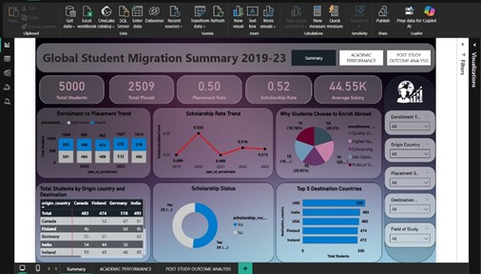
- Global Student Migration Report
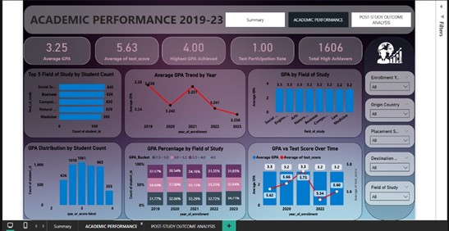
1.1: Global Student Migration Summary
1.2: ACADEMIC PERFORMANCE

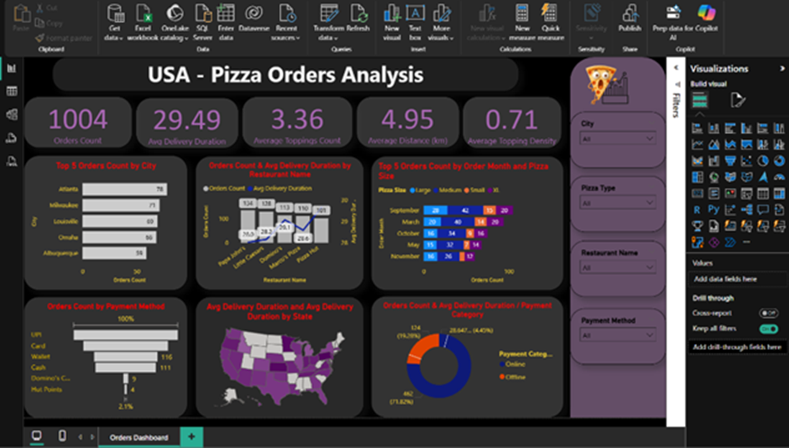
- Pizza Orders & Delivery Delay Analysis Dashboard – USA:
2.1: Orders Overview Dashboard
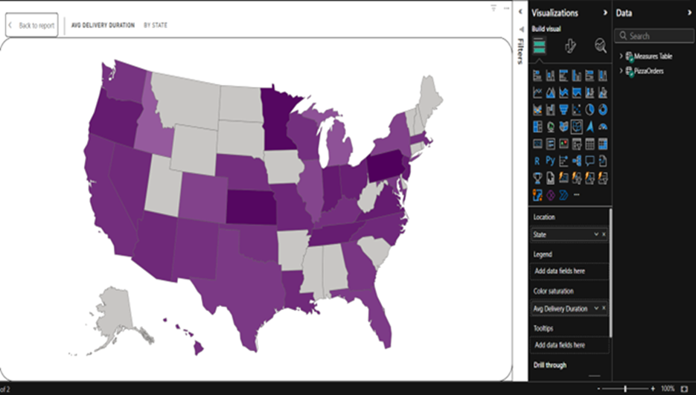
2.2: Geo-Level Map Visualization

- Google Forms → MySQL Automation:
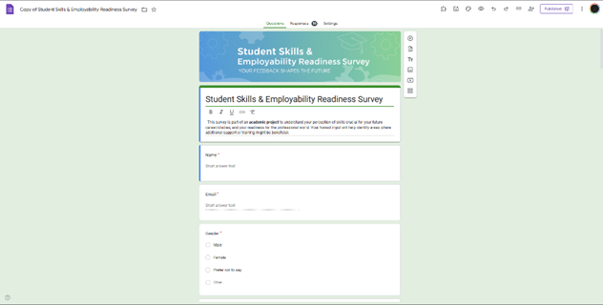
3.1: Google Form
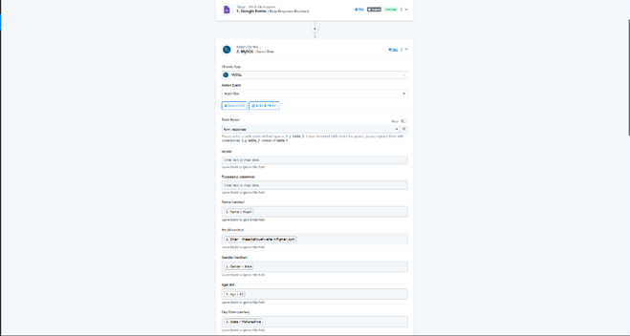
3.2: Integration of Google forms and MySQL

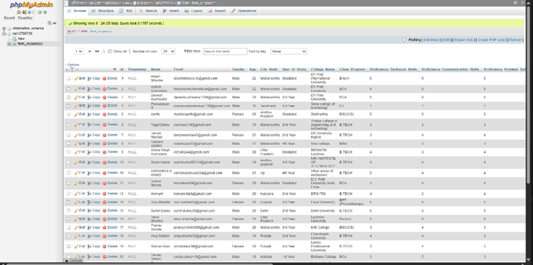
3.3: Integrated MySQL DataBase

4. Project GitHub Link
👉 Project Link

Learning and Reflection
New Learnings (Technology, Management)
1.Power BI & Data Visualization:
  - Learned how to clean, transform, and model datasets using Power Query.
  - Gained practical knowledge of DAX functions to create KPIs, measures, and calculated columns.
  - Improved ability to design interactive dashboards that present insights in a clear, executive-friendly manner.
2.Database Management (MySQL):
  - Strengthened understanding of relational databases and SQL queries.
  - Learned how to automate data entry from Google Forms into MySQL, ensuring accuracy and real-time availability.
  - Gained experience in validating, cleaning, and structuring database records for analysis.
3.Automation & Integration:
  - Acquired knowledge of integrating external tools (Google Forms, Google Apps Script/Python) with MySQL.
  - Learned how automation reduces manual effort and improves data consistency.
4.Project Management & Documentation:
  - Improved self-management skills by planning tasks, setting milestones, and completing the project within deadlines.
  - Learned the importance of version control and project documentation for clarity and reproducibility.

Overall Experience

Working on this project as an individual gave me valuable end-to-end exposure to real-world data handling and business intelligence. I experienced the complete workflow
from data collection and storage to dashboard development and automation.

This project helped me bridge the gap between theoretical knowledge and practical application, particularly in:
- Sales Analytics → deriving insights from raw sales data.
- Decision-Making Support → creating dashboards that highlight KPIs for business strategy.
- Database Automation → eliminating manual data entry through MySQL integration.
Overall, this project enhanced my technical, analytical, and problem-solving skills while also improving my ability to manage tasks independently. It has given me confidence to take on larger real-world projects involving data visualization, analytics, and automation.

Conclusion and Future Scope
Conclusion
1. Recap of Objectives and Achievements
The primary objectives of this project were to:
- Build interactive sales dashboards (Global Student Migration Summary) using Power BI to analyse sales trends, product performance, and customer behaviour.
- Automate data collection from Google Forms to MySQL to ensure accuracy, efficiency, and real-time accessibility.
Achievements:
- Successfully designed and implemented Power BI dashboards that provide valuable insights into sales, revenue, customer loyalty, and profitability.
- Developed an automation pipeline that transfers Google Form responses directly into MySQL, eliminating manual entry and reducing errors.
- Delivered actionable recommendations for improving sales strategy, inventory management, and customer engagement.
- Strengthened technical skills in Power BI, SQL, DAX, data cleaning, and automation scripting.

2. Future Scope of the Project
This project can be further enhanced and expanded in the following directions:
- Advanced Analytics & Forecasting:
Implement predictive models using Python or R to forecast sales trends and customer demand.

- Integration with Cloud Platforms:
Host data on cloud databases (e.g., AWS RDS, Azure SQL, Google Cloud SQL) for scalability and remote accessibility.
- Real-Time Dashboards:
Connect live data sources (APIs, streaming services) to Power BI for continuous, real-time updates.
- Mobile-Friendly Dashboards:
Optimize Power BI dashboards for mobile viewing so that executives can monitor KPIs on the go.
- Machine Learning Integration:
Incorporate sentiment analysis (customer reviews/feedback) and recommendation systems to enhance decision-making.

